Deepfake Detection with AI Tools: A Comparison of Accuracy and Limitations

Iufereva A.
IULM University, Milan, Italy
anastasiia.iufereva@studenti.iulm.it

Mozelius P.
Mid Sweden University, Sundsvall, Sweden
peter.mozelius@miun.se

Abstract: Image manipulation is a phenomenon much older than digital image handling and generative artificial intellingence (GenAI). In the digital era researchers have made a distinction between cheapfakes and deepfakes. The creation of cheapfakes requires a relatively little low technical editing level, and do not depend on any GenAI technology. This study had a focus on deepfakes only, and to explore the role of GenAI in the generation of deepfakes as well as the role of AI in tools for detecting deepfakes. The term deepfakes refer to high-quality and synthetic media content created with the use of deep learning and generative artificial intelligence. Recent advances in deepfake generation have made such content even more realistic, making it harder to identify. The rise of AI-convincing content is a growing social issue that poses serious challenges for its detection. Even though the importance of deepfake detection is widely recognized, the applied research remains limited. This study aims to evaluate the effectiveness of some selected deepfake detection tools. For this, a comparative analysis was conducted to assess the comparative performance of AI-driven tools. The testing was based on a set of images and videos generated by artificial intelligence based tools. Based on these findings, the accuracy and limitations of the selected AI tools were analysed and compared. Future research should focus on testing a broader range of AI-based detectors to evaluate their effectiveness against different types of deepfake, such as music, audio, text, including less sophisticated AI-generated manipulations as cheapfakes.
Keywords: Deepfakes, AI, GenAI, AI-Detection, Detection tools, Image manipulation

1. Introduction

2. Data collection

3. Results of analysis

4. Conclusion

References

Case 1. The dad with children in the Gaza Strip.
The example of a deepfake features an image of a father surrounded by his five children standing before a pile of rubble (Figure 2). This photograph, widely disseminated on X and Instagram, has been viewed hundreds of thousands of times in connection with Israel's bombardment of Gaza. However, a community notice on X now identifies the image as manipulated. “In the meantime, the image has been marked with a community notice, at least on X, that it is fake” (DW). For instance, the man's right shoulder appears unnaturally elevated, disrupting anatomical proportion. Equally peculiar are the two limbs extending beneath his sweater, giving the illusion of unnatural emergence. Moreover, the hands of the two boys embracing their father’s neck seem to merge indistinguishably, further distorting the composition. Additionally, discrepancies in the number of fingers and toes across several hands and feet in the image contribute to its overall inconsistency.
Image 1.. This Image displays various errors and inconsistencies that are typical for AI images”

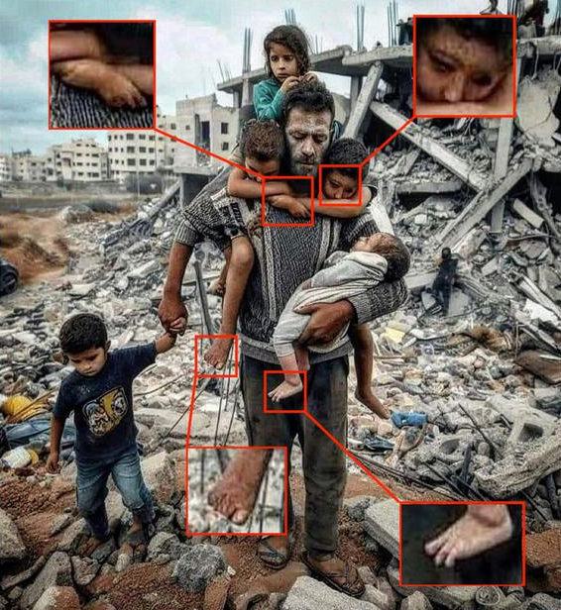

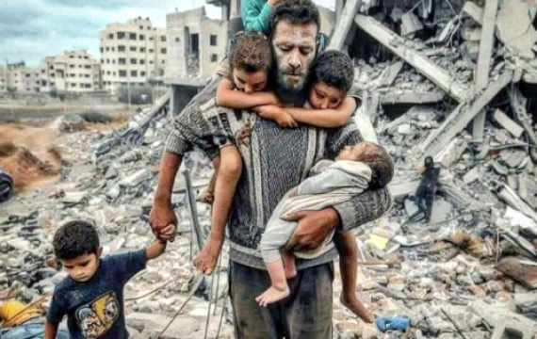
Source: personal archive of the authors (an example was demonstrated by the student Fausta Blasi as part of the Corso di Perfezionamento in Didattica della Shoah, University of Florence, 2024)

Case 2. A Palestinian boy
The image depicts a child gazing upwards with his arm raised, surrounded by rubble and the bloodied face of a veiled woman, purportedly his mother, who is said to have died following a bombing in Gaza. Initially shared by "several pro-Hamas accounts," the photograph quickly gained widespread circulation across numerous accounts on X, many of “which were flagged it as a fabricated creation” (Open). However, its authenticity has been questioned, with multiple users flagging the image as fabricated. Critical examination reveals significant inconsistencies: notably, the child’s left hand is depicted with six fingers. The presence of extra fingers, a common anomaly in AI-generated imagery, points to the likely use of free AI image generation software, which is prone to such errors. Additionally, a closer inspection of the child’s eyes and eyelashes reveals disproportionate enlargement compared to the rest of the facial features.

Image 2. Visual Symbolism and National Identity: The Emotional Impact of a Palestinian Boy’s Image

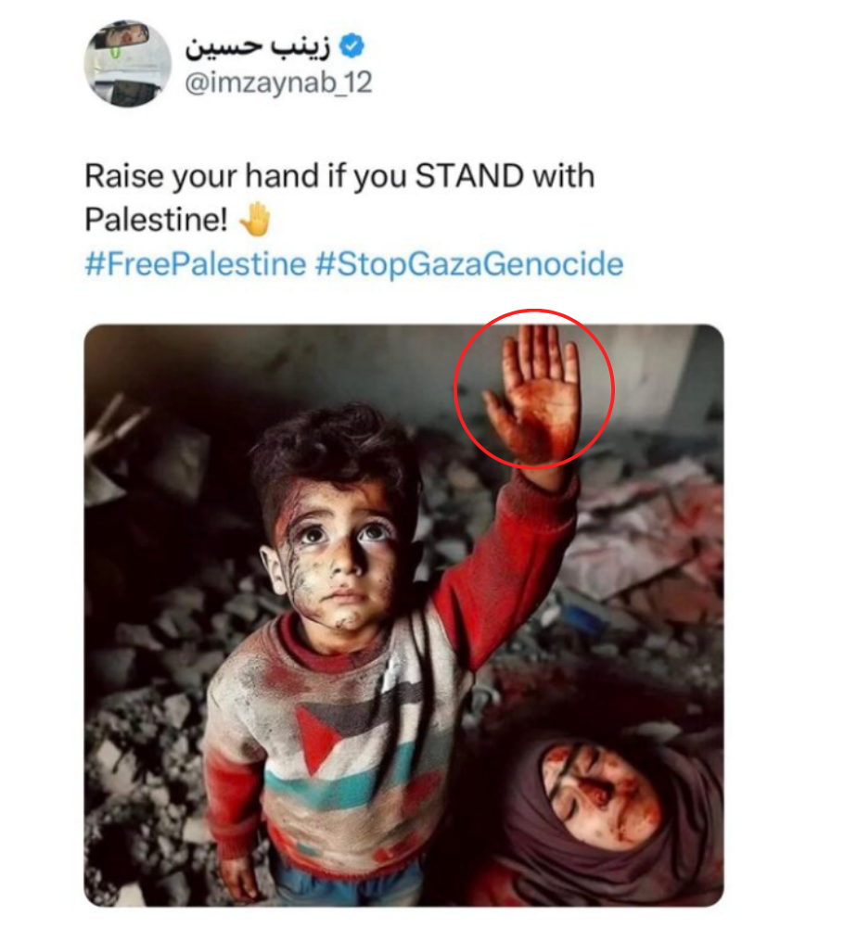
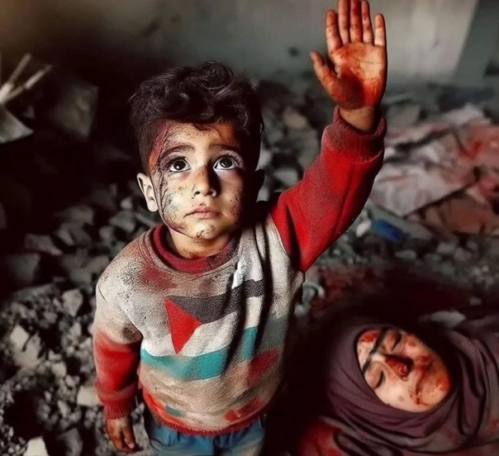

Source: personal archive of the authors (an example was demonstrated by the student Fausta Blasi as part of the Corso di Perfezionamento in Didattica della Shoah, University of Florence, 2024)

Case 3. "Patriotic Illusion: Signs of AI Generation in Depicting the Israeli Army"

The image below, depicting soldiers carrying Israeli flags while marching through a settlement of bombed-out houses, exemplifies evoking patriotic sentiments. However, upon closer inspection, several features undermine its authenticity. The movement of the Israeli flags appears unnaturally uniform, the central street is improbably pristine, and the debris exhibits an unusual level of uniformity. Additionally, the destroyed buildings resemble one another closely, positioned at remarkably regular intervals. Collectively, the overall visual effect is excessively "clean" and lacks the irregularities characteristic of real-life scenes. This kind of artificial flawlessness, often giving images a painted or staged appearance, is a hallmark of AI-generated content.

Image 3. Framing Emotion Through Imagery: The Role of a Israili Soldiers in National Narratives

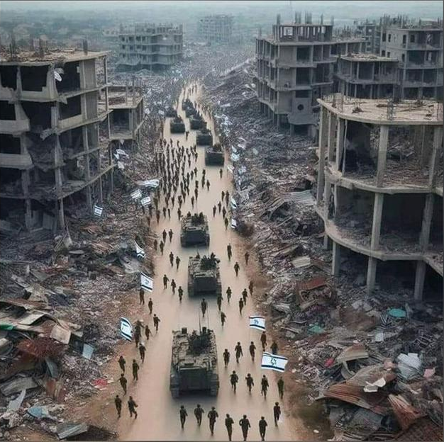
Figure 3. AI images circulating on social networks are usually capable of triggering strong emotions in viewers. URL: https://www.dw.com/en/fact-check-ai-fakes-in-israels-war-against-hamas/a-67367744

Case 4. Crowds and Israeli soldiers
An image depicting crowds on balconies cheering and waving Israeli flags as soldiers march along a street was created using AI for inspirational purposes as well. The image was widely shared on social media platforms accompanied by hashtags such as #HamasTerrorist and #IsraelFightsBack. On Facebook, it appeared with captions such as “The REAL Israel. Need we say more? AM YISRAEL CHAI!!” (The nation of Israel is alive) and its Spanish equivalent, emphasizing unity and resilience (see DW). However, the image has caused confusion among online users, many of whom question its authenticity and suspect it to be official propaganda. The original post was uploaded on October 11 by Omri Shefi as part of a collection of thirteen AI-generated images depicting civilians and soldiers waving flags and celebrating. In his post, Shefi stated that the images were created with AI as part of psychological warfare, aiming to envision victory. His caption read: “Much of this warfare is psychological. So, let's imagine our victory picture, and so it will be!” (translated from Hebrew). Despite the clarification regarding its origins, the image raised skepticism among social media users, with some accusing it of being fabricated for political messaging. This example underscores the potential for AI-generated imagery to blur the lines between artistic expression and propaganda, especially in the context of geopolitical conflicts.
Image 4. AI-Generated Depiction of Jubilant Crowds Waving Israeli Flags at Soldiers
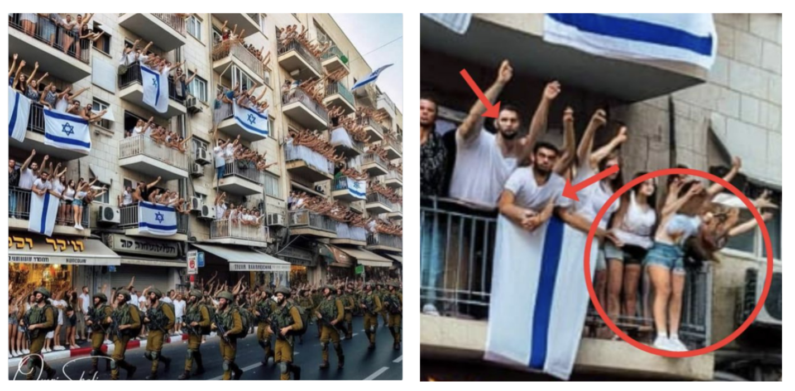

Here in more details: https://www.reuters.com/fact-check/photo-cheering-crowds-waving-israeli-flags-soldiers-is-ai-generated-2023-10-30/

Case 5. Crowds and Israeli soldiers

The presented photo went viral as well. It was published on several social media platforms (e.g., X, Istagram and Facebook) by palestiniani users. It purportedly depicts a palestinian family eating together in the rubble. This picture was create to evoke a spectrum of emotions as sympathy for Palestinian civilians.

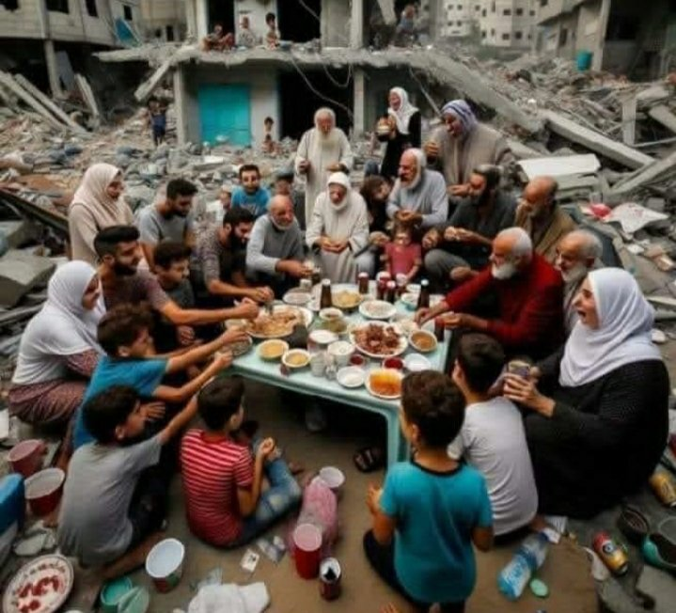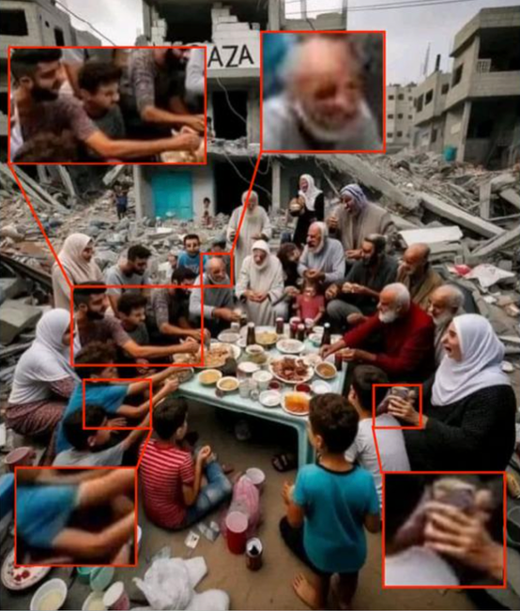

Here in more details: https://www.dw.com/en/fact-check-ai-fakes-in-israels-war-against-hamas/a-67367744

10 TOOLS FOR DEEPFAKES DETECTION

-1-

https://sightengine.com/detect-ai-generated-images

-2-

https://undetectable.ai/

-3-

https://decopy.ai/ai-image-detector/

-4-

https://wasitai.com/

-5-

https://hivemoderation.com/ai-generated-content-detection

-6-
https://app.illuminarty.ai/#/

-7-
https://matrix.tencent.com/ai-detect/ai_gen

-8-

https://detect-ai-images.web.app/

-9-

https://isitai.com/ai-image-detector/

-10-
https://aidetectcontent.com/ai-generated-image-detector/

Remark: I decided to concentrate on free available tools, since it is essential to make a focus on immediate effect of the AI detections outputs. Since, even common users could use it without the obligation to make the registration and pay. Probably, it might be as a limitation for this research. But I think it is justified. Moreover, I believe that all these tools must be free to provide everyone with the opportunity to check the data.

Peter, also I suggest presenting the results in this way (like the example to see effectiveness):

Table 1: Comparison results between AI deepfake detection tools

Tool | Pic 1 | Pic 2 | Pic 3 | Pic 4 | Pic 5
Name of Tool 1 | ✅ | ✅ | ✅ | ✅ | ✅
Name of Tool 2 | ✅ | ✅ | ❌ | ❌ | ❌
Name of Tool 3
Name of Tool 4
Name of Tool 5
Name of Tool 6
Etc.

